

SYSTEMS DIVISION

Book Depth eXpress (BDX)
Business Requirement and High Level Design Document
Document #Requirement Specification588
WR #5588

Prepared By: Manish Sharma
Last Modified Date: Feb 23rd, 2009

Approved by:

Mark Novak
Systems Division

Review Version

CBOE CONFIDENTIAL AND PROPRIETARY

Table of Contents
1 Introduction 4
1.1 Background 4
1.2 Purpose & Scope of this document 4
1.3 Functionality Implementation for Book Depth eXpress 5
1.4 Functionality Implementation for Future Phases 5
1.5 Proposed Design 5
2 System Overview 7
2.1 Current Book Depth Process Flow 7
2.2 Future Book Depth Process Flow 8
3 Requirement Analysis – Book Depth eXpress 9
3.1 High-level functionalities to be implemented 9
3.1.1 Market Data Buffer 9
3.1.2 Optimization Process 9
3.1.3 Define Book Depth firm API 9
3.1.4 BDX Cache and delivery to CFN 9
3.1.5 BDX – Trader Server Recovery / Control 10
3.1.5.1 Data Feed Subscriber Outage 10
3.1.5.2 CFN or Other Network Related Outage 10
3.1.5.3 BDX Outage 11
3.1.5.4 Internal Failover / Outage Scenario Processing 11
3.1.5.5 BDX Failover 11
3.1.5.6 BDX Detects Gap Or Fails to See Ping from BC In X Seconds 11
3.1.5.7 Refresh Cost To Trade Server And Duplicate Refresh Mitigation 11
4 BC Startup and Failover Scenarios 12
5 Implementation and Rollout changes in CBOEDirect 13

Document Revision History

Sr. No | Description | Date | Version | Created / Modified By
1. | Template Created - Overview | 08-22-2008 | Draft | Manish Sharma
2. | Updated with diagrams & features | 09-11-2008 | Draft | Manish Sharma
3 | Updated doc post review meetings | 02–23-2009 | Review | Manish Sharma

Introduction

Background
The goal of the Book Depth eXpress project is to deliver an Options book depth data feed over the CBOE Financial Network (CFN) using an Industry-Standard message format such as FAST (FIX Adapted for Streaming), and to do so with no additional latency cost to the Trade Server.
The functionality to deliver the top N book levels currently exists in CBOE Direct and is used to transmit Book Depth data to One Chicago and CFE customers. However, the format of this existing feed is implemented in inefficient ASCII encoding using a proprietary CBOE message format that is non-standard. CBOE wishes to use an industry-standard message encoding such as FAST, which improves efficiency. In addition, if possible without copyright or legal issues, CBOE wishes to use the same message format for Book Depth messaging as already exists in the industry elsewhere or at least something very similar. In doing so, the adoption of the CBOE Book Depth feed by customers should be easier because little or no coding would be required by customers.
In addition, this project comes at a time when the latency of Quote processing on the Options Trade Server is a serious concern, and attempts are being made via other projects to reduce it. Since Book Depth updates on every quote, the last thing the Trade Server can afford right now is additional processing that will increase latency. Because of this, another goal has been attached to this project, which is to “do no harm” to latency while at the same time implementing the Book Depth functionality in the Trade Server. This means the existing implementation cannot be used because it is known to add latency to the main Quote processing path in the Trade Server.
Tests were conducted to determine what the current implementation would do to latency in the Trade Server. It resulted in an unacceptable increase in processing times for Options quotes. A quote step-up test was conducted on the Options Trade Engine with and without the existing Book Depth functionality turned on.
The following are the results:
Test Scenario | CAS | avg resp time
38K step up baseline test | perfcas5 | 4.7 - 6.2ms
38K step up with book depth on | perfcas5 | 6.4 - 8.9ms

This testing show that transaction times increase from 36 to 43% with the existing Book Depth functionality turned on. This is deemed to be unacceptable so it must be “payed for” by refactoring the way it works and/or by possibly refactoring completely unrelated code in the Quote processing code path in order to offset the cost.

Purpose & Scope of this document
This document presents the results of business requirements gathering and analysis for the Book Depth eXpress that will be available to customers. The work involved:

- Requirement Gathering and Analysis
- Documenting the business requirements in the prescribed format

It describes the rollout implications and non-functional requirements that include the performance, the time constraints and monitoring & back up/recovery.

Functionality Implementation for Book Depth eXpress
For the Book Depth project following functionalities will be implemented:
- MarketDataBuffer utilities and application Codecs for Quote History and Book Depth.
  - The data for following fields will be provided to the CBOE Client for Book Depth:
    - Price, Professional Volume, Customer Volume
- Replace existing Quote History path out of TradeServer with data path that combines Quote History and Book Depth into a single MarketDataBuffer and publish to book depth channel.
- New BDX – Book Depth eXpress process(es) (does not run on BC) that will collect all Book Depth updates, reconstruct the order Book, and transmit Book Depth feed to CFN using IP Multicast and data formats that are FAST compliant.
- Product State

Functionality Implementation for Future Phases
Following functionalities will be implemented in future phases:
- Add Current Market
- Add Market Data History

Proposed Design
As part of the design, we are introducing the concept of a “market buffer”. The market buffer is essentially a sequence of bytes that can represent different pieces of information needed by the rest of the book depth processing functionality. Additionally, the market buffer can hold information needed by other CBOE process such as quote history, market data history etc.
The responsibility of the BDX will be to take the updates contained in the market buffer and do the following:
- keep track of the current book by product
- format book depth updates to be sent to the CFN
- multicast book depth updates to the CFN
- allow for data recovery from the BCs
- allow for book depth data snapshots to be sent to the CFN
- Publish book depth legacy for One CFE, Stock, Strategy
The BDX will be developed in a way in which it can be run in either a single Master/Slave cluster or multiple cluster distributed by multicast groups.
The book refresh and book snapshots sent to the CFN will be sent via multicast. Additionally, the data will be formatted according to the FAST FIX specification. Both the multicast and FAST FIX have rooted themselves as the emerging standard for the delivery of book depth information.
In order to facilitate our help desk and operation areas, the book depth data will be retrievable via the SAGUI as its currently working.
The end users receiving the data from the CFN will see the following:
- Individual book updates by product
- Periodic full book updates (to N levels) for each product
- Security definition

Book Depth Processing Flow
The following diagram shows the high level design of the book depth message processing:
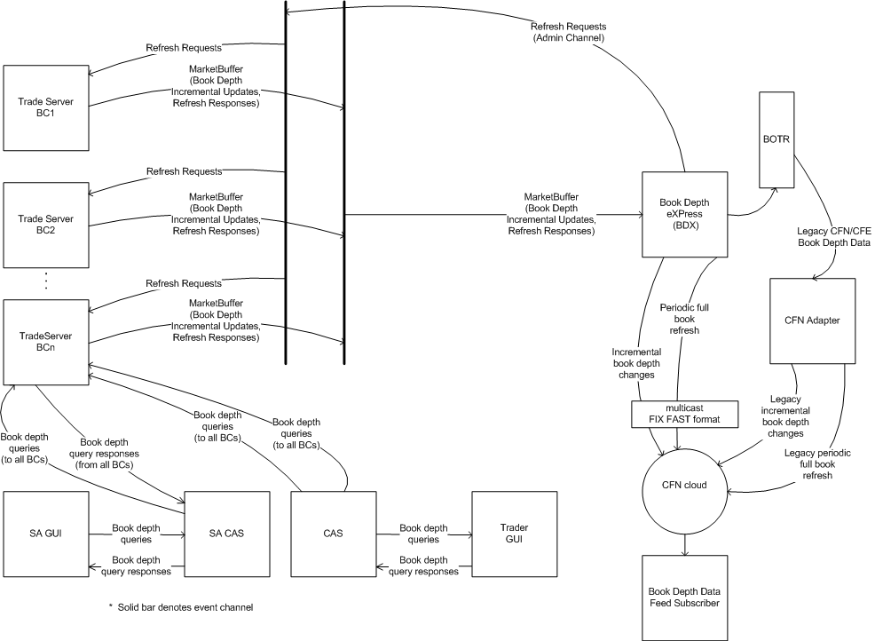

System Overview

Current Book Depth Process Flow
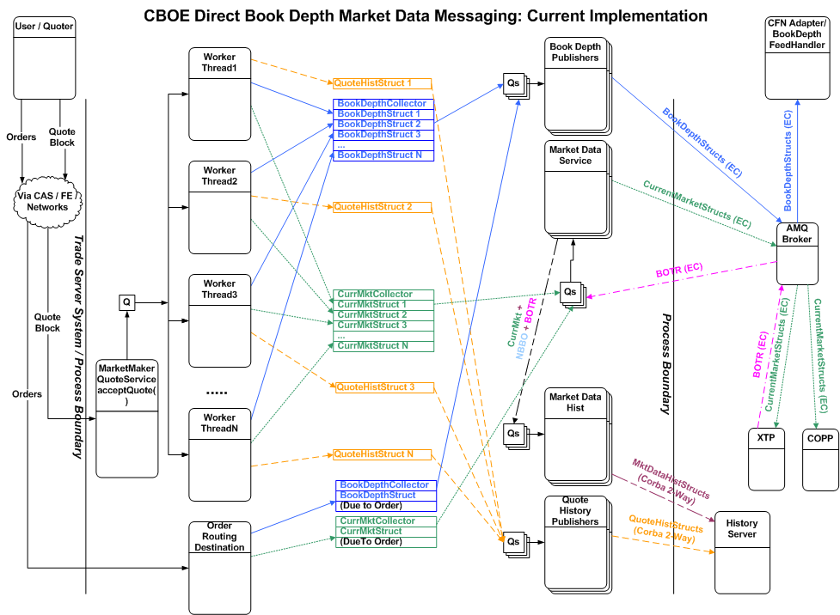
The diagram below shows the data flow of Book related data in the Trade Server.

Future Book Depth Process Flow
The diagram below shows the new data flow of Book related data in the Trade Server
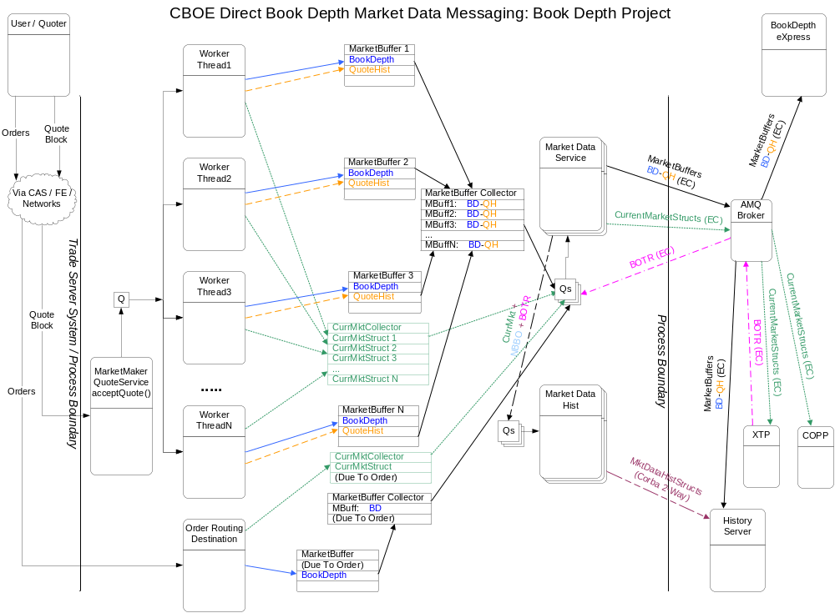

Requirement Analysis – Book Depth eXpress

High-level functionalities to be implemented

Market Data Buffer
To consolidate different kind of data to be published into a single entity that occupies contiguous memory, a logical choice is to use a byte array and store the data in serialized format.
The idea for the market data buffer is relatively simple. For every set of correlated results of a transaction, create one MarketDataBuffer. In the case of an individual quote update, its corresponding artifacts, Quote History, Book Depth update, and Current Market update would all be stored in this one buffer. As part of the broader transaction that represents an entire block of quotes, a collector that ties together the individual MarketDataBuffers together would also be built. Each quote update and it’s artifacts occupy one buffer and act as one unit of delivery to a downstream process.
One problem with passing around encoded data in serialized format is to insure that knowledge of how the bytes are physically stored and the order of the fields in the encoded data are strictly limited to a single or very small number of Java Classes, and to enforce some kind of encapsulation. In addition, as knowledge of how to better compact data and better encode it in the future comes about, some kind of upgrade path provision for adding new fields, supporting new types of encoding, etc. must be supported.
To facilitate encapsulation of how primitive types are encoded and decoded a “Codec” (coder / decoder) is contemplated for each kind of primitive type, and where necessary, for small business-level objects (such as prices and other small commonly used structures).
Field level primitive Codecs are assembled into groups (like a struct) or sequences (like an array) and ultimately into a “Message Codec” which represents some business-level structure “template”. Access to a Message Codec is controlled by the business-level implementation of that Message Codec. The access is similar to the way one would access IDL-generated Java structs, except the fields are not public and can only be accessed via methods, which makes it better encapsulated. Further, the business-level Message Codec is in control of what fields can be modified and the interface in which they modify them. If necessary, validation could be done to insure invalid values are not allowed, and all kinds of things are possible since the business Message Codec is a Java object that is written and is not generated code like IDL.
The Message Codec knows how to encode itself into and decode itself from a MarketDataBuffer. Access to the MarketDataBuffer will be controlled so that only Message Codecs may access it’s physical storage directly.

Optimization Process
Please refer to the optimization doc attachment.

Define Book Depth firm API
CBOE Fast Book Depth specification will be provided to the firm.

BDX Cache and delivery to CFN
The BDX is a new process. It is contemplated it will be based on XTP software because it seems like a natural fit and many of the building blocks required to implement it are available in XTP.
The BDX will take Refresh and incremental Book Depth updates from each BC and store it in a Cache, which will be a reconstruction of the Order Book’s price levels, but without the individual quotes and orders.
When a book entry is updated, the BDX will figure out what levels of the book changed and will fire an update event. Attached to that update event will be code that knows the format of the data required for the data feed to be transmitted out the CFN. That data will be queued to another Thread that will then attach a sequence number and encode the data into FAST format and transmit it out a Multicast group to Data Feed Subscribers.
Please find the diagram for the process structure of BDX below:
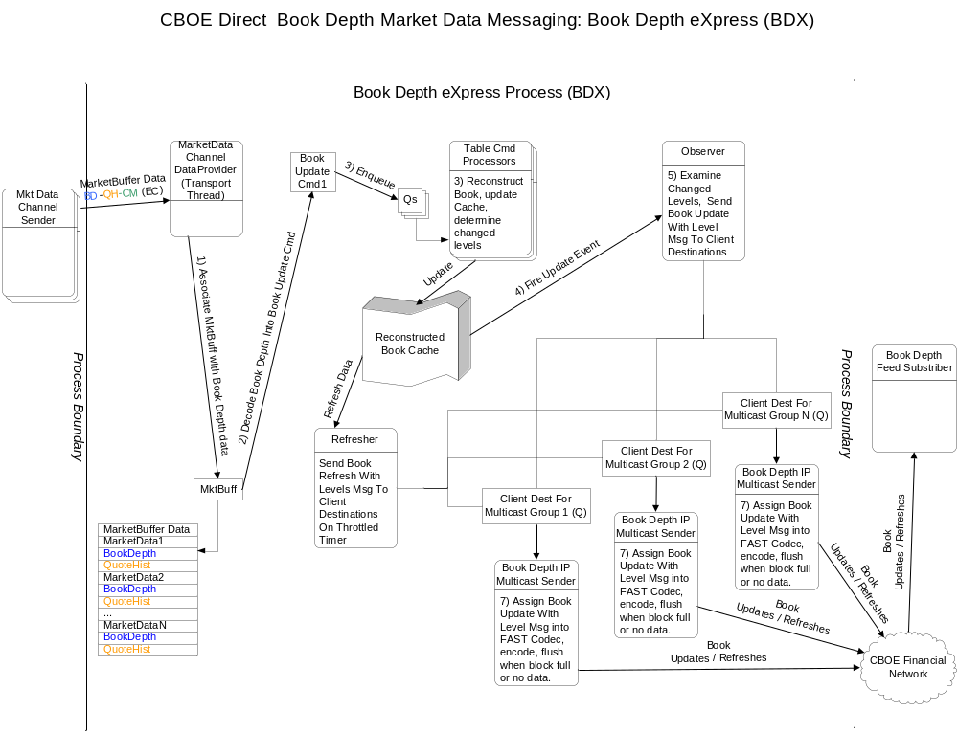

BDX – Trader Server Recovery / Control

Data Feed Subscriber Outage
In the event a Data Feed Subscriber goes down and comes back up, they should zero-out their book entries for all products or mark them unusable, etc. The Subscriber must wait for a Refresh message for a particular product before using it for trading. Incremental messages for the same product may appear, but they should be discarded until a Refresh message for that product appears.

CFN or Other Network Related Outage
The Subscriber to the Book Depth Feed will get 2 duplicate sets of Book Depth feeds over different IP Multicast groups and ports and over different physical networks in order to handle single-network outages.
In the event of a dual-network outage, the Subscriber should either detect that there is no data for some small period of time (a few seconds) or a sequence gap should be detected. In either case, all products that are transmitted over the problematic Multicast Feed should be considered stale.

BDX Outage
In the event of a BDX outage, the backup BDX will take over processing, however, this failover may take a few seconds. During the failover time period, the Subscriber should detect no data arriving for some number of seconds. When the backup BDX takes over, it will issue a new sequence number that is higher than the last known sequence number.

Internal Failover / Outage Scenario Processing
Between the BC and the BDX, there will be a “Ping” or “heartbeat” message that is transmitted every few seconds. In addition, all messages between BC and BDX are sequenced to insure nothing is dropped and if something is dropped, that it can be detected. Below are the outage scenarios and actions:

BDX Failover
The BDX will have a primary and a backup (Master/Slave). Both will receive Book Depth updates and will keep a Cache that reconstructs the Book. They will operate independently with regard to internal outage scenarios that follow.
However, in the event of a failover between the primary / backup, a failover will do the following:
- Disable the outbound feeds on one BDX
- Enable the outbound feeds on the backup BDX
The act of enabling the outbound feeds activates the following processing:
- The continuous refresh will be started and runs at a faster rate.
- After this initial refresh is completed, the normal speed continuous refresh is transmitted.
As described above, Data Feed Subscribers should detect this failover by either lack of data or by the sequence gap that will occur when the backup becomes the primary. Data Feed Subscribers should trigger their recovery mode and wait for the next Refresh for any given product.

BDX Detects Gap Or Fails to See Ping from BC In X Seconds
In this scenario, there is a gap in the sequence numbers coming from the BC, or there is the absence of data from a particular BC in some number of seconds. These scenarios are identical with respect to the BDX viewpoint, and it does the following:
- Walk the Book Cache for those products that are updated via the BC for which the outage was detected and mark them to ignore incremental update.
- Mark the book entries for each product so that a full Refresh is required before incremental updates will be accepted again.
- Wait for a message from the BC for which the sequence gap or lack of data was detected. AFTER the ping arrives, request a Refresh from that BC.
Once a Refresh is seen for a particular product, it’s book is updated, the “ignore incremental update” flag is turned off, and a Refresh is sent to all Data Feed Subscribers. This is how things get back to normal.

Refresh Cost To Trade Server And Duplicate Refresh Mitigation
When a refresh of the Book is requested from BDX to the Trade Server, this activity increases the load on the Trade Server for the duration of the refresh. Because of this, strategies will be implemented to minimize the load on the TradeServer and to prevent duplicate or excessive refreshes from being requested by BDX.
To limit the cost a refresh request has on the Trade Server, it will single-thread all refresh requests, and it will throttle them. Single-threading the requests causes only one to execute at a time, so if any duplicate refresh requests were to be issued, they would wait until the current request completes. To prevent the refresh processing from interfering with normal trade and quote processing, the refresh will be throttled since it requires that tens of thousands of products' Books be transmitted to BDX. The throttle will use a batch size to limit the number of products that are refreshed at a time. Every batch-size products, the refresh software will sleep for some period of time to let other parts of the Trade Server to execute normally.
In addition to throttling and single-threading the refresh, software will be written in BDX to mitigate the frequency at which it may request a refresh from the Trade Server. To accomplish this, BDX will remember when it last requested a refresh, and will disallow another refresh request from being sent until the Trade Server responds with a "refresh completed" message, which is sent after a full all-products refresh is transmitted. This way at most only one request can be outstanding at a time.

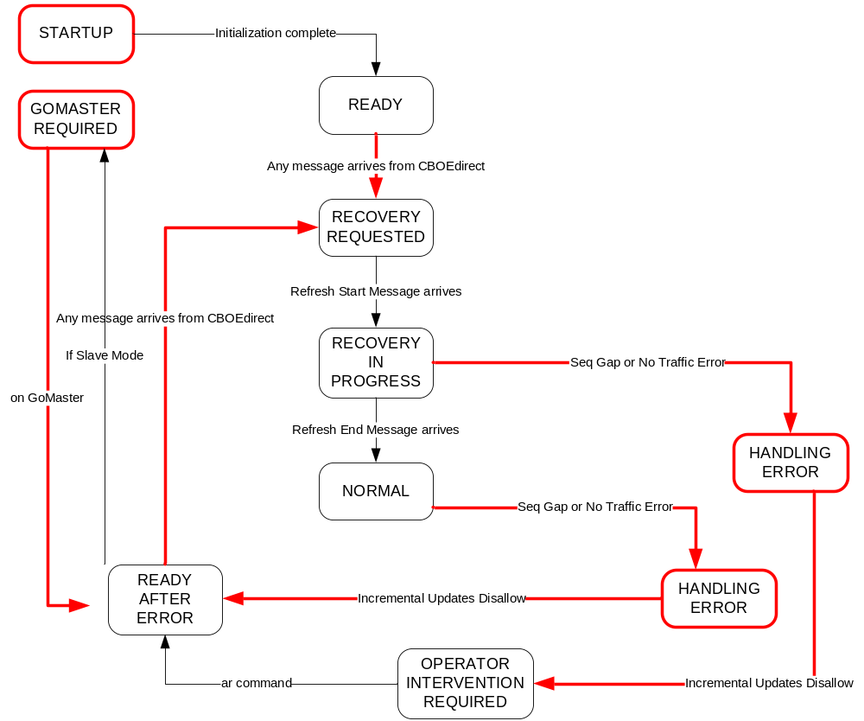

BC Startup and Failover Scenarios
At BC startup and in a BC failover scenario, there is a step where the BC rebuilds it’s order book. When this occurs, the BC should transmit a Ping message to the BDX to indicate it is ready to accept a Refresh request.
If the BDX is active, it should be in a state where it thinks the BC is down and it should be waiting for the Ping from the BC to trigger its request for a Refresh.

Implementation and Rollout changes in CBOEDirect
Changes will be made for:
- BC
- Bridge
- BDX

